# Characterizing Riparian Vegetation Using the Riparian Classification from LiDAR (RCL) Tool in ArcGIS

Authors: Sky Jones1; Racha El Kadiri2, PhD; Henrique Momm3, PhD;

1Middle Tennessee State University, [rj3h@mtmail.mtsu.edu](mailto:rj3h@mtmail.mtsu.edu)

2Assistant Professor, Middle Tennessee State University, [racha.elkadiri@mtsu.edu](mailto:racha.elkadiri@mtsu.edu)

3Asssociate Professor, Middle Tennessee State University, [henrique.momm@mtsu.edu](mailto:henrique.momm@mtsu.edu)





## Abstract

*The Riparian Classification from LiDAR (RCL) tool is a Python script designed to classify riparian land cover. The tool accepts a folder of LiDAR binary (*.las*) files and outputs a land use raster as well as supporting data files such as digital elevation and slope models. It is available as an ArcGIS script tool, meaning it can be called using the same graphical user interface that standard ArcGIS tools use. This document details how to set up and use the RCL tool.*

## Assumptions

This walkthrough assumes that the user is generally familiar with ArcMap and has already obtained LiDAR data in *.las* format for their study area, either by directly downloading *.las* files or unpacking *.laz* (compressed *.las*) or *.zlas* (ESRI compressed *.las*) files. Optimal results will be achieved with LiDAR data having a point density of over 1pt/m2.

It is not necessary that the user is familiar with any scripting languages. The *.las* files for the study area should be contained within a single folder with no other files.

The RCL tool requires ArcGIS 10.X and valid Spatial and 3D Analyst licenses to run.

## Walkthrough

1. *Downloading the RCL Tool*

The RCL tool can be found at <https://github.com/rsjones94/nrcs_rcl>. To download the tool, click the green “Clone or download” button and select “Download ZIP” **(Figure 1)**. Unpack the zipped folder in a location that can be easily found later. This folder contains the RCL Python script and the associated ESRI Toolbox file, as well as supporting documentation (including this walkthrough).

1. *Running the RCL Tool*

To open the RCL interface, open ArcCatalog. The Catalog can be accessed either directly in the ArcCatalog application or through ArcMap by clicking the “Catalog” button in the toolbar. In the Catalog navigate to the folder downloaded in the previous step. Double click on *rcl.tbx* to expand it, then double click the *Riparian Classification from LiDAR* tool to open the tool dialogue **(Figure 2)**. A graphical user interface similar to standard ESRI tools will appear. Fill each field as instructed by the tooltips.

IMPORTANT: Your *.las* files MUST be in a projected coordinate system that uses meters as its XY units. RCL classification relies on scale-dependent phenomena; XY units supplied as feet or degrees may result in incorrect classification.

When ready, hit run. Processing time varies with study area size and LiDAR point density. For large study areas (*.las* files totaling over 5gb) processing times of 30 minutes and beyond are common if a clipping shapefile is not supplied. Tool progress can be monitored under “Messages” in the Results pane, which is accessible in the Geoprocessing dropdown menu. The tool will progress through the following steps

Generating footprint and .lasd>Generating DSM>Generating DEM>

Generating DHM>Generating slope rasters>Classifying cover>Classification complete

Once the tool has finished running, the classification raster can be found in the output folder specified in the tool parameters along with a support folder full of generated data products **(Figure 3)**. The values in the classification raster will depend on whether the classification scheme selected was “binary” or “ternary”.

## Model Details and Limitations

It is recommended that all the LiDAR data for the study area is coterminous. The tool generates interpolated rasters, meaning data gaps due to distant, unconnected LiDAR tiles will be interpolated across even if the distance is large. This results in expensive, unnecessary computations.

Additionally, though this model is most accurate within the riparian corridor, it will output a raster that classified the entirety of the LiDAR input unless a clipping shapefile is supplied **(Figure 4)**. Because classification done outside the riparian corridor has limited accuracy, it is recommended that the user either clip the output classification using a riparian buffer polygon or supply a clipping shapefile at runtime.

## Figures

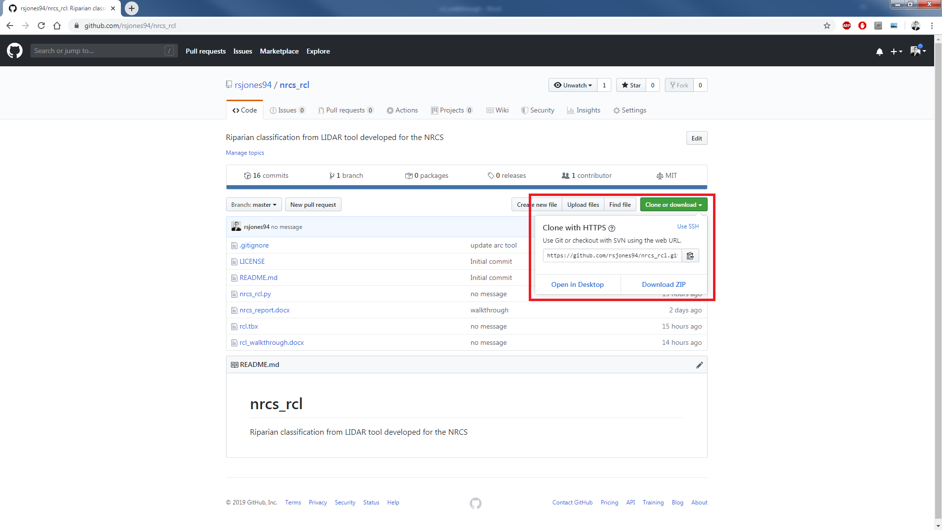

**Figure 1.** The RCL tool can be downloaded from the nrcs_rcl Github repository.

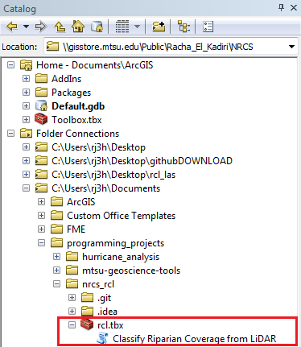

**Figure 2.** The directory structure of the RCL toolbox in the Catalog. Double-clicking *Classify Riparian Coverage from LiDAR* will launch the RCL tool user interface.

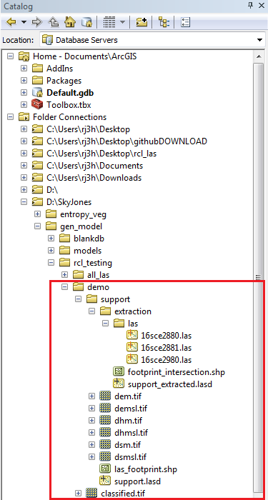

**Figure 3.** The directory structure of the RCL tool output in the Catalog. The *extraction* subfolder only appears if a clipping shapefile is specified at runtime.

**Figure 4.** Sample output for the RCL tool demonstrating the restriction of the output to the union of the extent of the combined LAS footprint and a clipping shapefile. The output shown uses the ternary classification scheme.

## Acknowledgements

Many thanks to the National Resources Conservation Service for providing funding for this project.